Project Design Phase-II Technology Stack (Architecture & Stack)

|  |  |
| --- | --- |
| Date | 18 October 2022 |
| Team ID | PNT2022TMID06675 |
| Project Name | Project – EMERGING METHODS FOR EARLY  DETECTION OF FOREST FIRES |
| Maximum Marks | 4 Marks |

Technical Architecture

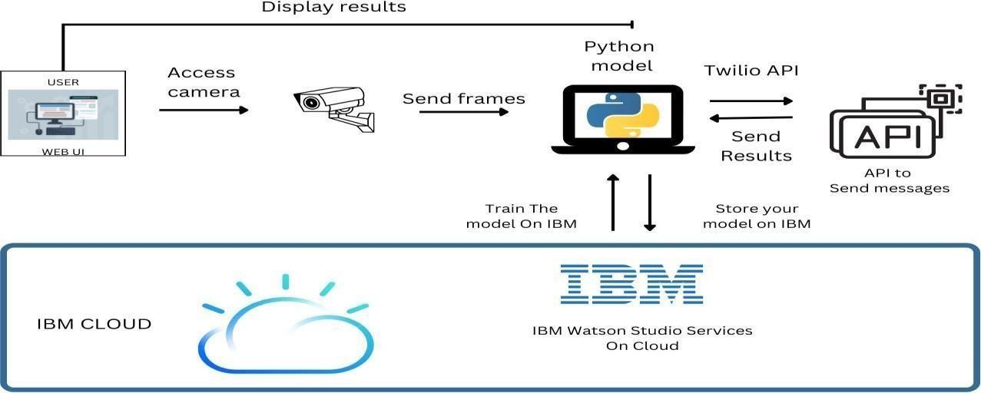

Table-1 : Components & Technologies:

|  |  |  |  |
| --- | --- | --- | --- |
| **S.No** | **Component** | **Description** | **Technology** |
| 1. | User Interface | The user uses the console to access the interface | Python/HTML ,CSS , Javascript and  react.Js |
| 2. | Input | Video Feed | Web Camera/Video on a site |
| 3. | Conversion | Video inputted is converted into Frames | Frame Converter |
| 4. | Feeding the Model | The Frames are sent to the Deep learning model | Our Model |
| 5. | Dataset | Using Test set and train set , train the model | Data set from Cloud Storage , Database |
| 6. | Cloud Database | The model is trained in the cloud more precise with detections more images can be added later on. | IBM Cloudant ,Python Flask. |
| 7. | Infrastructure (Server / Cloud), API | Application Deployment on Local System / Cloud  Local ,Cloud Server Configuration , Twilio API to send messages | Java/python ,React.Js ,JavaScript  ,HTML ,CSS ,IBM Cloud ,OPEN CV  ,Anaconda Navigator ,Local. |

Table-2: Application Characteristics:

|  |  |  |  |
| --- | --- | --- | --- |
| **S.No** | **Characteristics** | **Description** | **Technology** |
| 1. | Open-Source Frameworks | Python Flask framework is used | Technology of Opensource framework |
| 2. | Security Implementations | Mandatory Access Control (MAC) and Preventative  Security Control is used | e.g. SHA-256, Encryptions, IAM  Controls, OWASP etc. |
| 3. | Scalable Architecture | High scalability with 3-tier architecture | Web server – HTML ,CSS ,JavaScript  Application server – Python , Anaconda Database server –IBM DB2 |
| 4. | Availability | Use of load balancing to distribute traffic across  servers | IBM load balancer |
| 5. | Performance | Enhance the performance by using IBM CDN | IBM Content Delivery Network |